Damage Classification and Localization for Composite Plates with Temperature Variance Using Deep Learning

Nicholas Muccioli
Lawrence Technological University Electrical and Computer Engineering
Course: EEE 5653 Software Development for AI
Professors: Dr. Mohammad Hassanzadeh and Dr. Jegan Rajendran

Abstract This paper investigates the damage classification and localization for carbon fiber-reinforced polymer composite plates under temperature variance conditions using deep learning techniques. The study evaluates the effectiveness of different deep learning models, specifically Convolutional Neural Networks (CNNs) and Multi-Layer Perceptron (MLPs), in identifying damage and its location while successfully accounting for temperature variations.
I. Introduction Carbon fiber-reinforced polymers are utilized across many different fields, including aerospace, civil, automotive, etc. These materials usually operate under a variety of conditions; temperature is the most common variable to change in their environment. Non-destructive testing is a frequent and essential approach used to detect defects in these polymers. Materials are commonly damaged in forms that are unviewable. Guided wave signal processing and extracted features can be accurately used for the detection and classification of such damage.
II. Theoretical Framework
A. Baseline Subtraction and Optimal Baseline Selection
Baseline selection is a method that subtracts a reference signal from the analyzed signal, or vice versa, to remove similarities like structural elements. The issue with this method is that under differing environments, signals vary due to the changing material properties of the pieces. Optimal Baseline Selection (OBS) solves this by selecting a baseline signal that has similar temperatures to the analyzed signal. A collection of reference signals is gathered and compared based on their temperature to avoid significant discrepancies.
B. Baseline Signal Stretch (BSS)
BSS is used in structural health monitoring to stretch a baseline signal by small amounts (using a stretch factor Alpha) to account for environmental and operational condition (EOC) effects. Methods evaluated for BSS include using an optimization function to find the minimum phase difference between the stretched baseline and the current signal, as well as using cross-correlation.
C. Wave Speed Cross Correlation and Spectral Density
Wave speed can be found by evaluating the lag between the cross-correlation of the input and output signals.
Equation of Cross Correlation can be seen below.
$$z\left[k\right]=\sum_{l=0}^{N-1}{x_{l}}y*_{l-k}$$
Equation 1: Cross Correlation
The resulting wave speed is able to roughly track whether the plate is damaged. Shown below is the graph from [12].
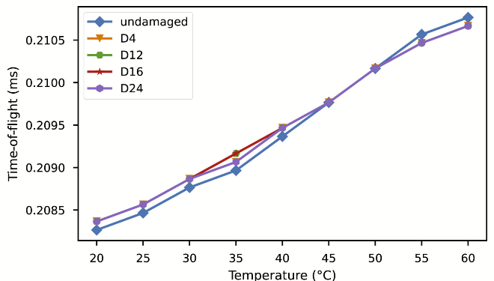
Figure 1: Relationship between time of flight, temperature and classes, adapted from source [12].
Cross-correlation is computed similarly to a convolution for two one-dimensional arrays. Once the lag and the distance between sensors are determined, the wave speed can be calculated. Furthermore, periodograms are computed using the Digital Fourier Transform to provide the Power Spectral Density of a time series, equivalent to the magnitude of the DFT squared. The Discrete Fourier Transform is shown below with x_{n} as the input signal and N as the size of the array.
$$X\left[k\right]=\sum_{n=0}^{N-1}{x_{n}}e^{\frac{-j2Πkn}{N}}$$
Equation 2: Discrete Fourier Transform
D. Machine Learning Frameworks
- Convolutional Neural Network (CNN): Used to add locational context to deep learning features by layering microfeatures into macrofeatures.
A | B | C | D | E | F | G | H | I | J
Z | Y | X | W | V | U | T | S | R | Q
Table 1: Example CNN array
- Multi-Layer Perceptron (MLP): Forward-propagating neural networks operating on weighted sums fed into an activation function. Loss is computed through back propagation, reducing loss in each epoch. Shown in the equation is g the activation equation, b the bias, x_{i} which is a one-dimensional array of inputs, w_{i} which are the individual weights for each input.

$$y = g(b+\sum_{i=1}^{m}{x_{i}}w_{i})$$
Equation 3: Machine Learning neuron

- Dimensionality Reduction and Clustering: Principal Component Analysis (PCA) is used for dimensionality reduction by isolating directions in feature space with the most variance. DBSCAN clustering was used to group points within a maximum range (eps) requiring a set number of points, classifying outliers as noise.
III. Experimentation and Methodology
A. Dataset Experiments were performed using the Open Guided Waves Dataset 2, which features temperature variance across 966 total measured plates. The dataset contains 322 baseline plates and 161 measurements for each of the 4 specific damage locations: D4, D12, D16, D24. From these, 80 plates in the baseline set are utilized for OBS.
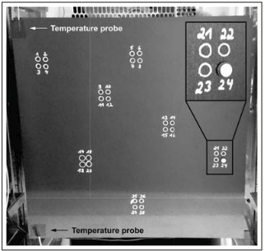
Figure 2: Experimental setup with damage locations adapted from source [3]
B. Project Design Several architectures were tested. In one, the PCA method fed directly into an MLP, the model attained 70% accuracy after 10 epochs. Another method utilized a custom feature map incorporating wave speed, wave magnitudes, and frequency magnitudes.
The primary architecture proposed was a CNN-to-MLP stack. The CNN module utilized 2 layers of Conv2Ds (2x10) followed by max pooling (2x2), concluding with a 1x2 max pooling layer. This output was passed to an MLP for classification. Initially, a "Super Stack" was created using 5 layers starting at 512 neurons and halving until it was 64 then moving to the classifier layer. Due to the high number of parameters, the model was subsequently reduced to "Normal Stack" and "Micro Stack" models (2 layers with modified neuron counts). All models were trained for 50 epochs.
IV. Results and Discussion Model training was conducted using CPU only. The super stack took approximately 15 minutes to train. The downsized stack model required roughly 10 minutes to train, and the micro stack model completed training in about 8 minutes.
When comparing performance to external literature, the accuracy of both the stack and super stack models were similar when operating on comparable data. Unlike previous studies that relied on Singular Value Decomposition to create a robust temporal damage index from 6 channels, this proposed model leverages 2D Convolutions to achieve a similar successful result.
The trainable parameters of the micro stack was ~13.5 million, stack was ~26.8million, and super stack was ~107 million.
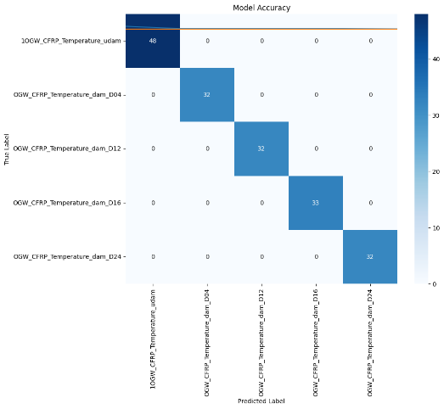
Figure 3: Confusion Matrix of Stack and Super Stack
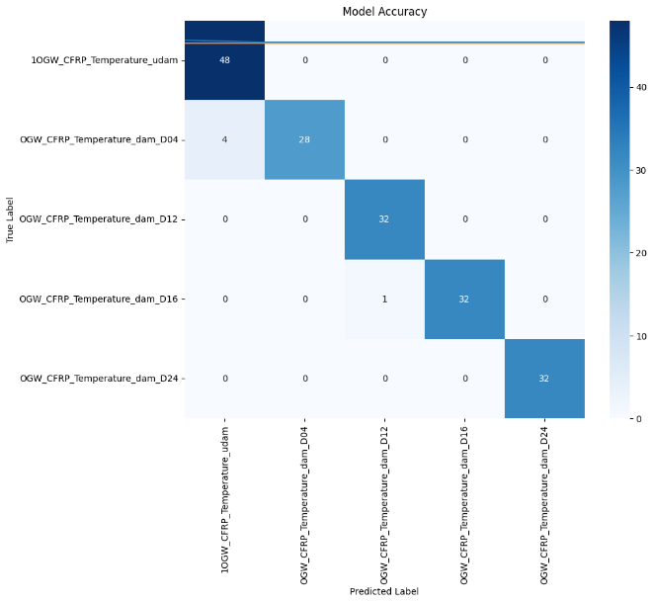
Figure 4: Confusion Matrix of Micro Stack
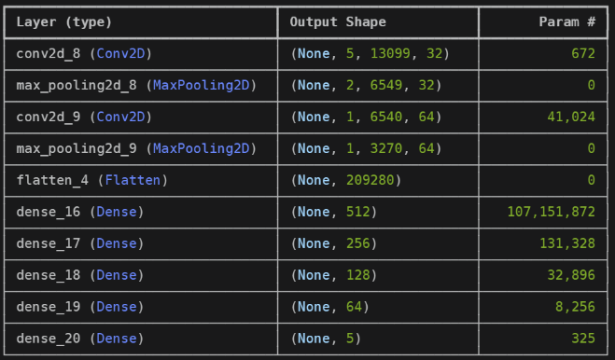
Table 2: Model Summary of Super Stack
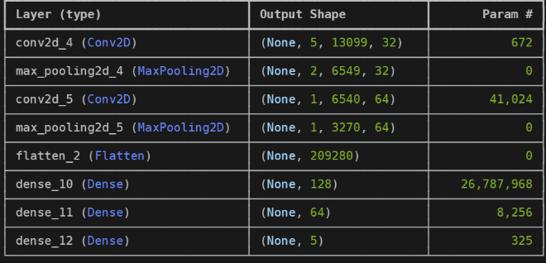
Table 3: Model Summary of Stack
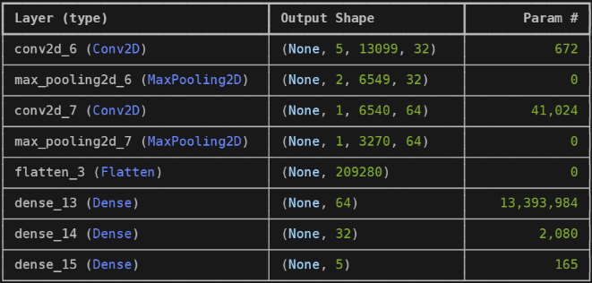
Table 4: Model Summary of Micro Stack

V. Conclusion and Future Work
The resulting deep learning models constructed were highly effective at identifying damage and localizing it while actively accounting for temperature variations.
Future improvements include implementing a full convolutional stack to establish cross-correlation for wave speed, refining the Baseline Signal Stretch (BSS) technique, and optimizing parameters to achieve 100% accuracy using smaller trainable parameter sets. Additionally, future work aims to mature the PCA approach to produce a functional unsupervised model.
Note: Google Gemini was used to translate the presentation that was made on this topic into a paper. Figures were added and additional information was added to round off the paper.
References:
[1] S. Zong, S. Wang, Z. Luo, X. Wu, H. Zhang, and Z. Ni, “Robust Damage Detection and Localization Under Complex Environmental Conditions Using Singular Value Decomposition-based Feature Extraction and One-dimensional Convolutional Neural Network,” Chinese Journal of Mechanical Engineering, vol. 36, no. 1, May 2023.
[2] A. Mardanshahi, V. Nasir, S. Kazemirad, and M. M. Shokrieh, “Detection and classification of matrix cracking in laminated composites using guided wave propagation and artificial neural networks,” Composite Structures, vol. 246, p. 112403, Aug. 2020.
[3] J. Moll et al., “Open Guided Waves: online platform for ultrasonic guided wave measurements,” Structural Health Monitoring, vol. 18, no. 5–6, pp. 1903–1914, Dec. 2018.
[4] IBM, “Support Vector Machine,” IBM, Dec. 12, 2023.
[5] V. Giurgiutiu, “GUIDED WAVES,” Structural Health Monitoring, pp. 185–238, 2008.
[6] K. Diamanti and C. Soutis, “Structural health monitoring techniques for aircraft composite structures,” Progress in Aerospace Sciences, vol. 46, no. 8, pp. 342–352, Nov. 2010.
[7] IBM, “What is principal component analysis (PCA)?,” Ibm.com, Dec. 08, 2023.
[8] IBM, “Convolutional Neural Networks,” Ibm.com, Oct. 06, 2021.
[9] M. El Mountassir, S. Yaacoubi, and F. Dahmene, “Reducing false alarms in guided waves structural health monitoring of pipelines: Review synthesis and debate,” International Journal of Pressure Vessels and Piping, vol. 188, p. 104210, Dec. 2020.
[10] GeeksforGeeks, “DBSCAN Clustering in ML Density based clustering,” GeeksforGeeks, May 06, 2019.
[11] "scipy.signal.correlate — SciPy v1.7.0 Manual,” docs.scipy.org.
[12] A. Abbassi, N. Römgens, F. F. Tritschel, N. Penner, and R. Rolfes, “Evaluation of machine learning techniques for structural health monitoring using ultrasonic guided waves under varying temperature conditions,” Structural Health Monitoring, p. 147592172211075, Jun. 2022.
[13] S. SAWANT, S. BANERJEE, and A. SETHI, “DAMAGE IDENTIFICATION FOR GUIDED WAVE TESTING OF COMPOSITE STRUCTURES USING STATISTICAL FEATURES,” Proceedings of the 14th International Workshop on Structural Health Monitoring, Sep. 2023.

[14] Google. “‎Gemini.” Gemini.google.com, 2024, gemini.google.com.

